**Indian Institute of Technology Patna**

**Dept. of Electrical Engineering**

**Bihta, Patna, Bihar – 801106**

**Name -** Madan Kumar Jha

**Roll No. –** 2411EE23

**Project** – Classical PLL

**Ring Oscillator and VCO**

**Theory:**

A **ring oscillator** is a type of oscillator circuit consisting of an odd number of inverting logic gates (such as NOT gates or inverters) connected in a loop. Due to the inherent propagation delay of each gate, the signal continuously toggles between high and low states, generating a periodic oscillation. The frequency of oscillation depends on the number of stages (inverters) and their delay characteristics. Ring oscillators are widely used in integrated circuits for clock generation, performance monitoring, and randomness generation in hardware security applications. Their simple design and ease of integration make them a common choice for on-chip frequency synthesis and testing**.**

A **Voltage-Controlled Oscillator (VCO)** in a Phase-Locked Loop (PLL) is a key component responsible for generating an output frequency that varies based on an applied control voltage. The PLL continuously adjusts this voltage to lock the VCO's frequency and phase to a reference signal, enabling precise frequency synthesis and clock recovery. The VCO’s frequency deviation is determined by its gain factor (Hz/V), making it crucial for maintaining stability and minimizing jitter in communication systems, microprocessors, and RF applications. Its ability to dynamically adjust frequency makes it essential for frequency modulation, demodulation, and synchronization in digital and analog circuits.

**Circuit Diagrams:**

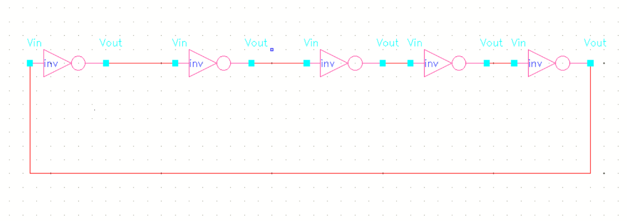

**Fig 1:** Block Diagram of a 5 stage inverter-based ring Oscillator

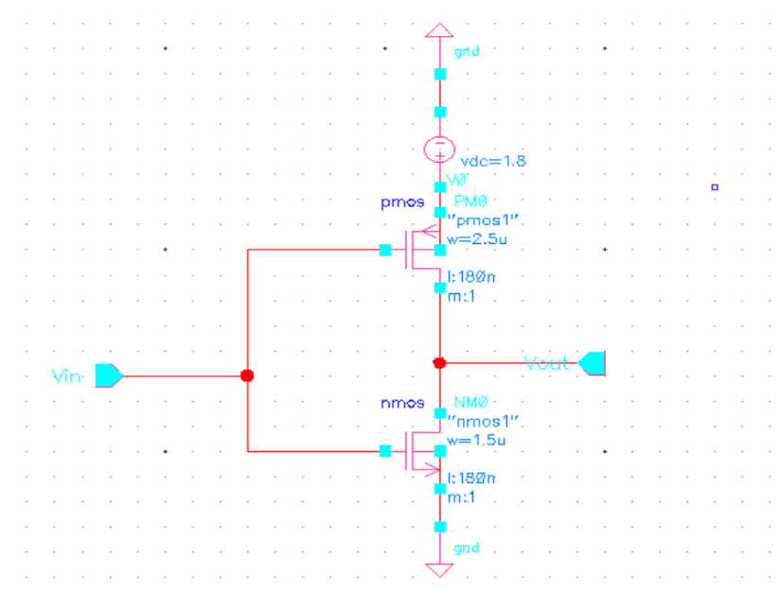

**Fig 2:** One inverter of the ring oscillator

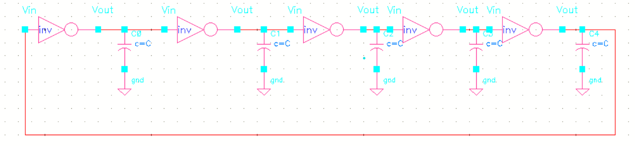

**Fig 3:** Capacitively loaded ring to reduce the Oscillation frequency.

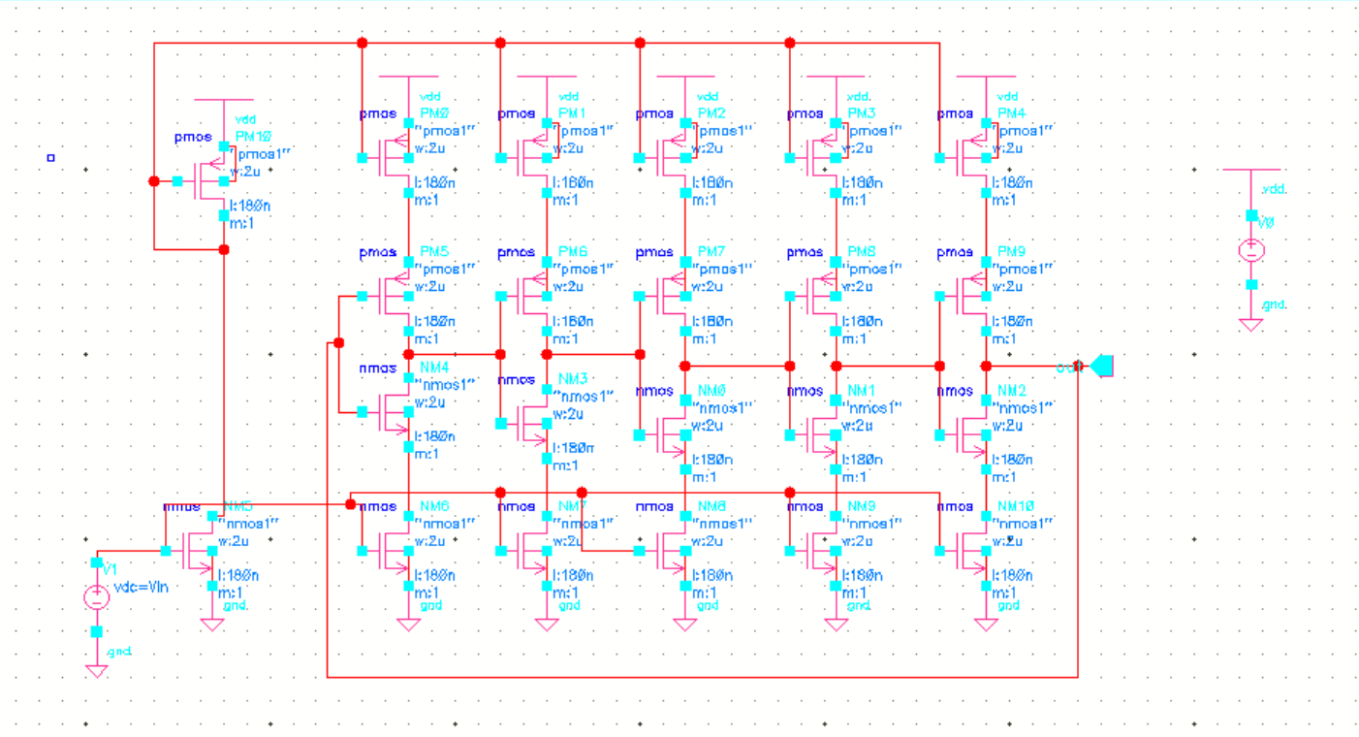

**Fig 4(a):** Current – starved ring Voltage Controlled Oscillator

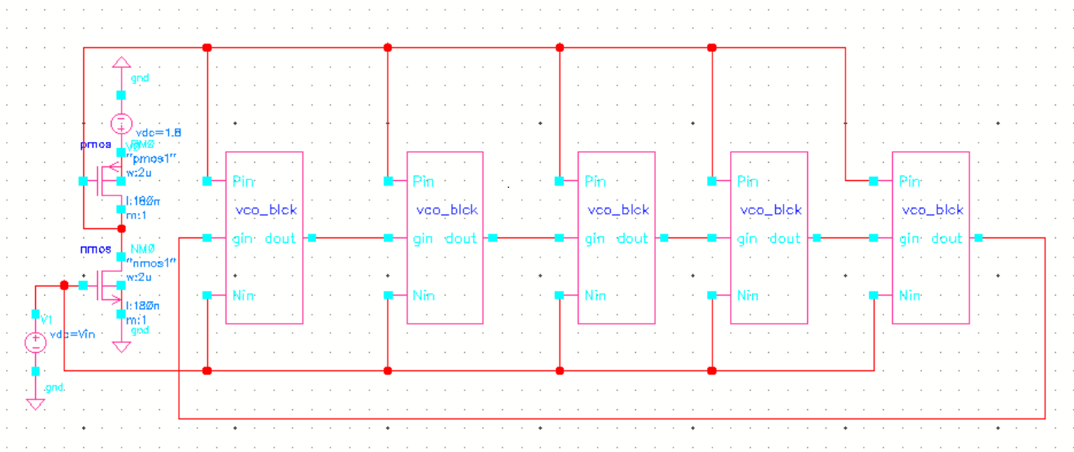

**Fig 4(a):** Circuit diagramof current – starved ring voltage controlled oscillator in cadence

**Result:**

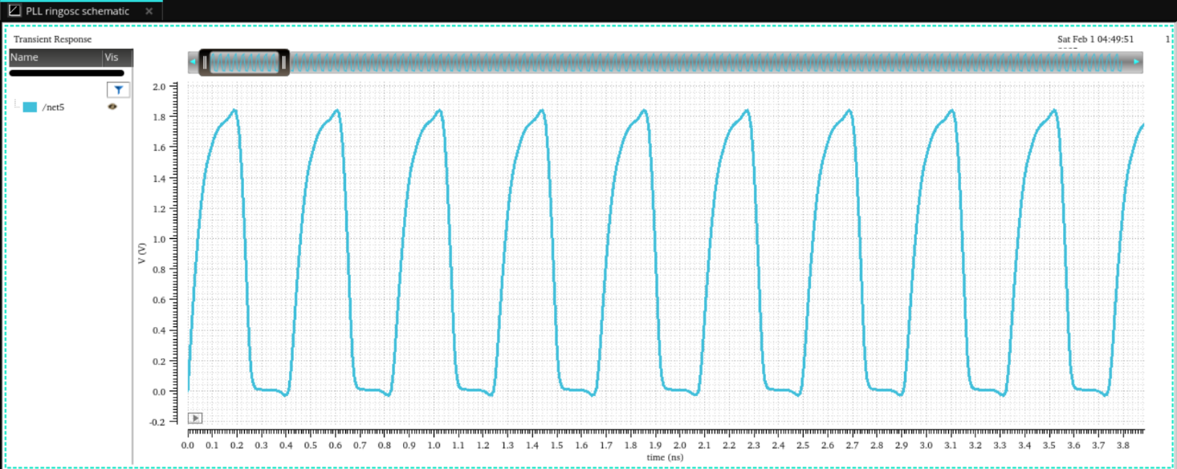

**Fig 5:** Output waveform of a 5 stage ring oscillator

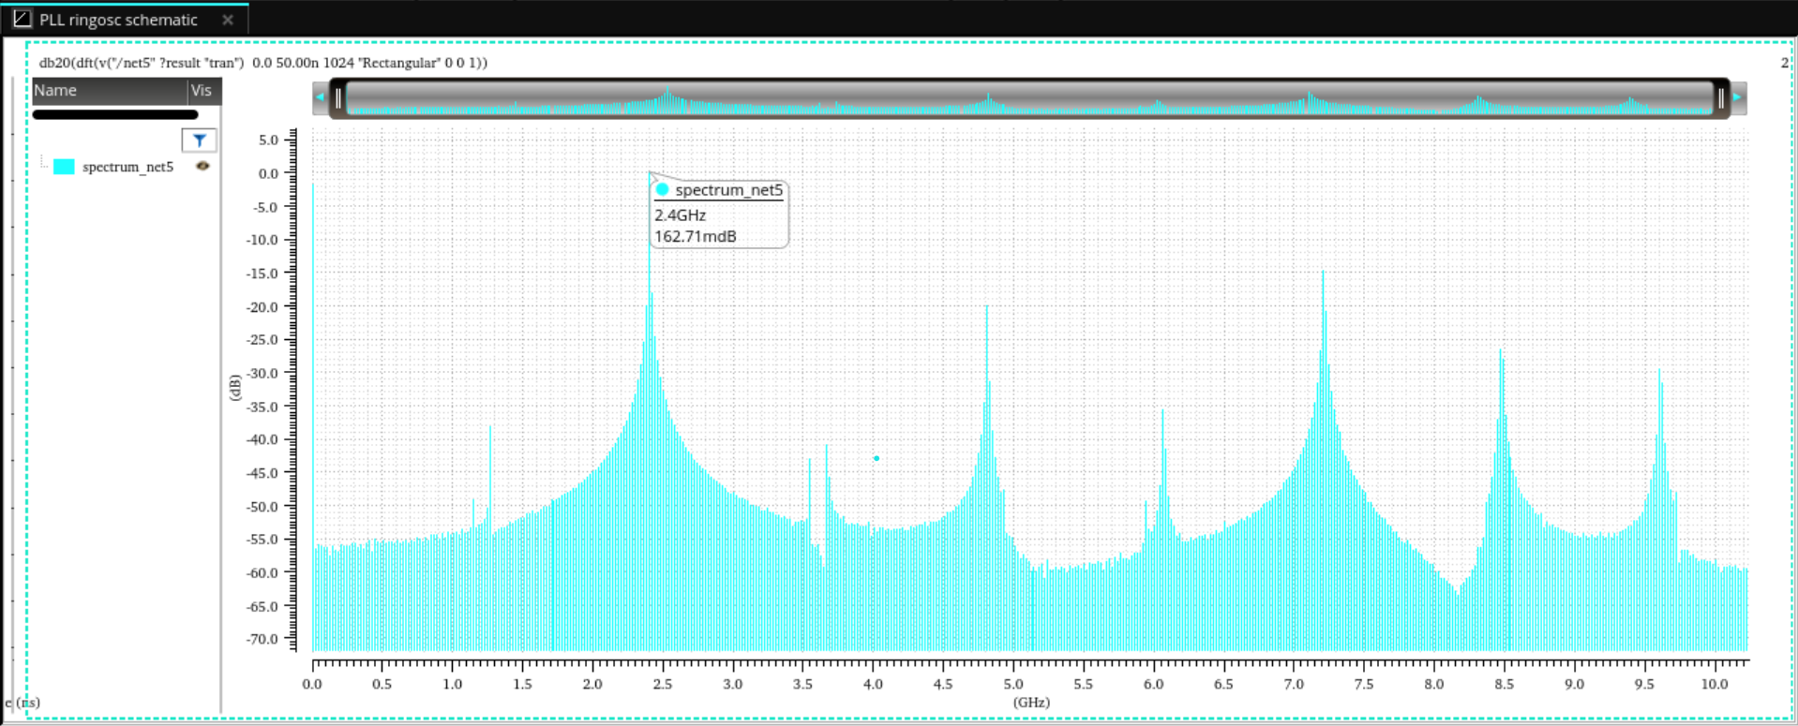

**Fig 6:** Frequency plot of 5 stage ring oscillator

At C= 5f Farad, fout =2.4 GHz

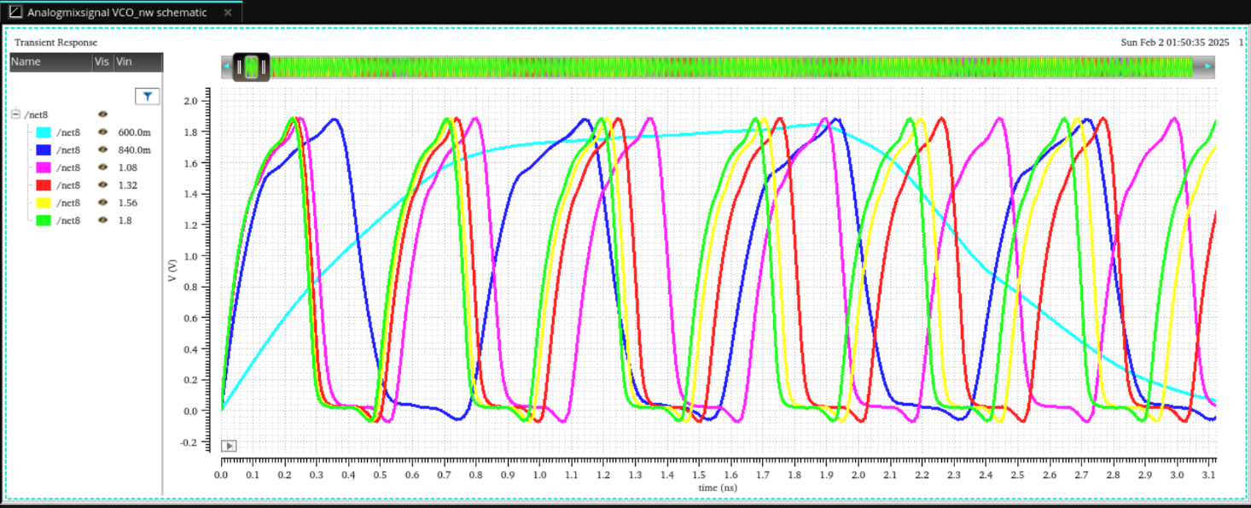

**Fig 7:** Output waveform of VCO using Parametric analysis

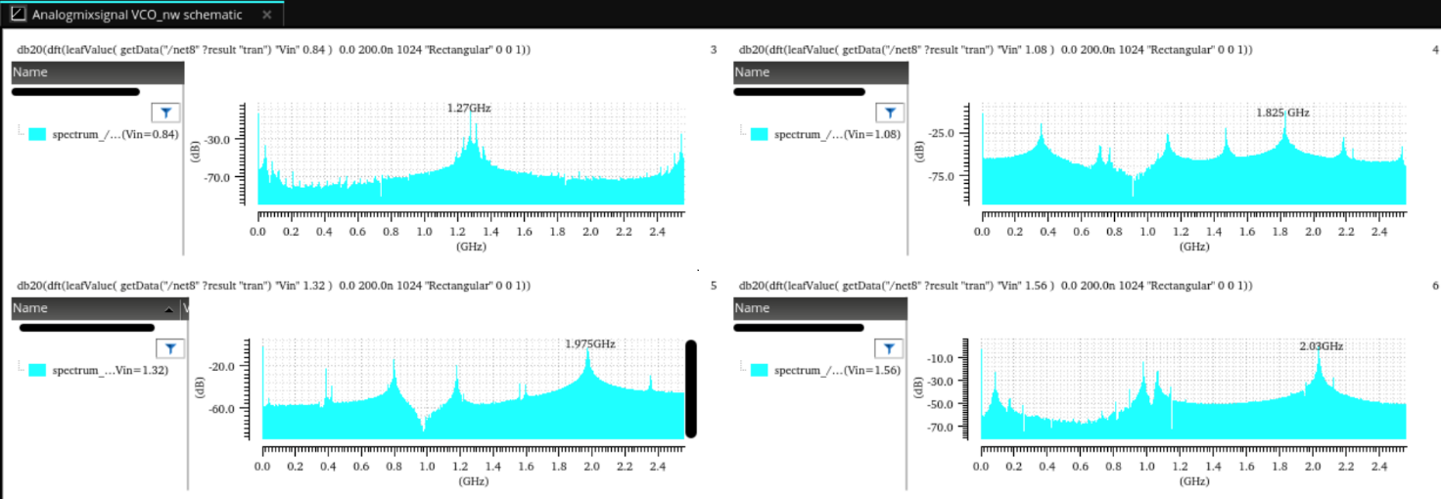

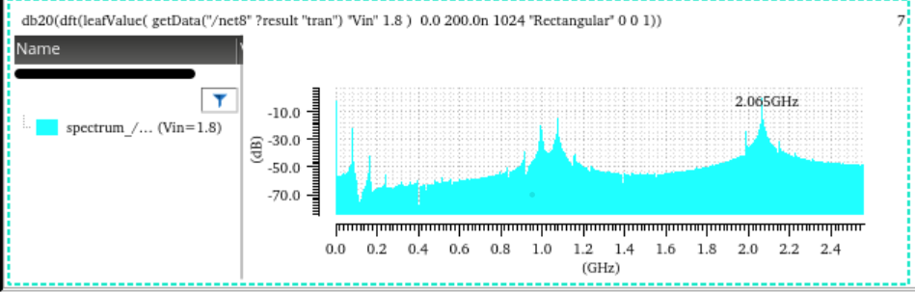

**Fig 8:** frequency plot at different control voltage label.

|  |  |
| --- | --- |
| Vin | Frequency(GHz) |
| 0.84 | 1.27 |
| 1.08 | 1.825 |
| 1.32 | 1.975 |
| 1.56 | 2.03 |
| 1.8 | 2.065 |

**Table 1:** Vin and frequency data

**Fig 9:** frequency vs control voltage graph